ACLARA or UNIFLO G4SZV
Information on how find your top up code and use this type of Smart PAYG meter.

How to enter your top up code
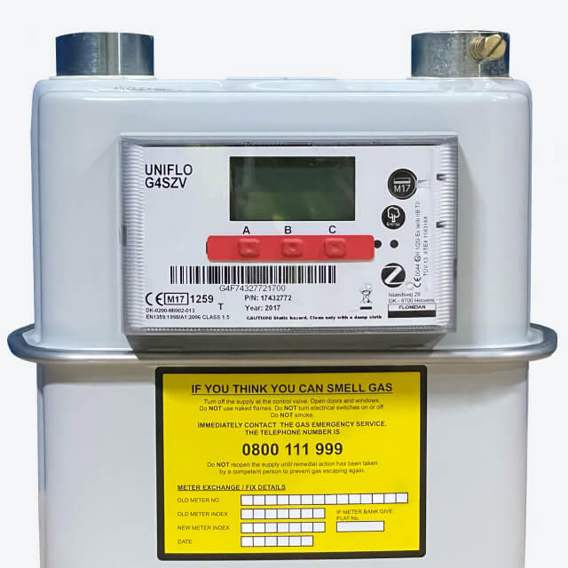

- Press any button to wake up the display, then press button ‘C’ to bring up the menu and select "PREPAYMENT".
- Press button B to scroll down to ‘NEW PAYMENT’.
- Press button C to select ‘NEW PAYMENT’.
- The words ‘Enter UTRN’ will appear on the screen.
- Use the up arrow (button A) to move through the digits until you reach the first of your top up code/UTRN.
- Use the right arrow (button B) when you’re ready to move to the next number. Continue doing this until you’ve entered all 20 digits.
- Once all 20 digits have been entered, press button C.
- If the UTRN has been successful, the display will show ‘TOP UP ACCEPTED’ and return to the menu.
- If the top up has not been successful,’ INVALID TOP UP’ will appear, and the meter will return to the ‘ENTER UTRN’ screen.

How to turn your gas back on
First you need to check that there's nothing been left on that might be dangerous if your gas was to start up.
- Press any button on the front screen to turn on the meter display.
- Press button A and ‘Safe open sequence’ will appear on the screen.
- The display will then show a series of messages and countdowns as the supply is reconnected.
- It will then return to the main screen and the gas supply should now be reconnected.
- For safety, if the meter detects any gas flowing while turning back on it will turn itself off again until the flow is stopped. If this happens, please check all gas appliances to make sure there's nothing left on then try again from the start.

How to activate Emergency Credit
- When your meter balance is £2 or lower, you can access your Emergency Credit.
- Press any button on your meter until you see the "EC" or "emergency credit" display.
- The display will show you the amount of emergency credit available to you. Press the "B" button to confirm that you want to use the emergency credit.
- Once you have confirmed that you want to use the emergency credit, the meter will automatically add the credit to your balance.
- The amount of emergency credit available to you will be deducted from your next top-up. You will also be charged a daily standing charge for the use of the emergency credit, which will be deducted from your meter balance.

